Freightliner has an App available to you!
Freightliner Smart Source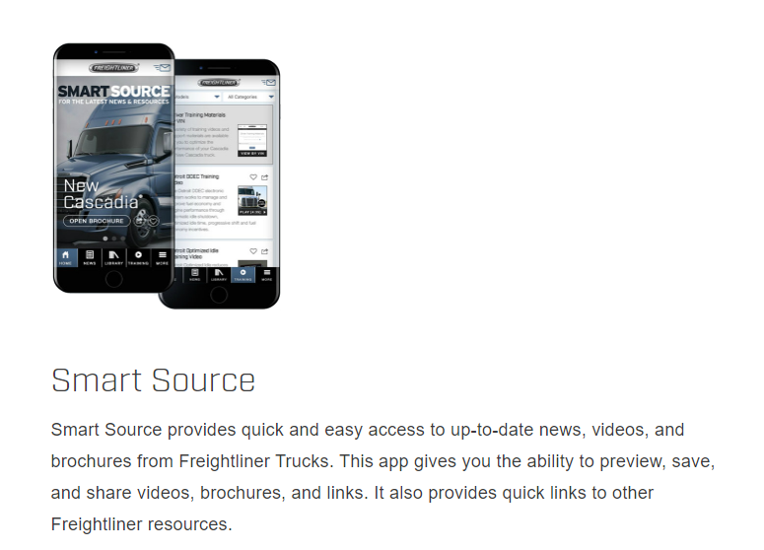
Smart Source provides quick and easy access to up-to-date news, videos, and brochures from Freightliner Trucks. This app gives you the ability to preview, save, and share videos, brochures, and links. It also provides quick links to other Freightliner resources.
Download the App on your phone to view videos and read brochures on different model years for Collision Mitigation, Adaptive Cruise Control and more.
Enter last 6 digits on a Vin

2021 Bunk, vin # MC8815  2021 Day vin # MC8760 | 2018 Bunk vin # JJ4154  2018 Day vin # JJ4136
2020 Bunk vin # KU5776  2020 Day vin # LP1667 | 2017 Bunk vin # HP2247  2017 Day vin # HP2231
2019 Bunk vin # JZ6576
2019 Day vin # JZ6578

